An Overview on COVID-19 In Pakistan

***Disclaimer:*** *Detailed information may contain mistakes and oversights from the real information or realities involved. Please refer governmental data source directly for decision making.*



**COVID-19 In Pakistan**

**Introduction and Background:**

Corona is a Latin word means “halo” or “crown”. Today it has enormously influenced everyone in the course of life since the last few months. First corona virus case was encounter in 1960 in U.K and USA. But COVID-19 is the most dangerous among all. I have created dashboards which are showing useful insights of the effect of Corona virus in Pakistan and their details are given below.

**Data Description:**

Data is taken from Kaggle by Mesum Raza Hemani covering the recent details of corona virus in Pakistan.

**Tool:**

I have used tableau public for making interactive visuals.

**1. Territorial Analysis of COVID-19 Confirmed Cases:**

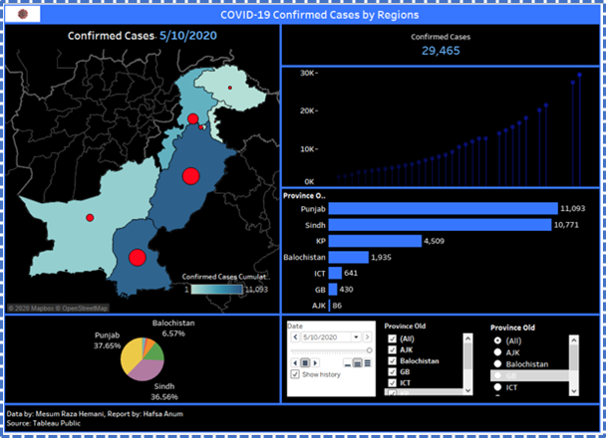

**Confirmed Cases**

**Components:**

This dashboard has 5 major components:

**· MAP:** It represents the expansion in confirmed cases. This is based on longitudes and latitudes. Details are shown according to provinces. For pane latitude Color shows the Confirmed Cases whereas size shows sum of confirmed cases.

**· Line Chart:** This is showing the trends of cumulative confirmed cases according to date. The data is filtered on provinces.

· **Bar Chart:** It shows comparative investigation of cumulative Confirmed cases for each province.

**· Count:** It shows the total count of confirmed cases as per date.

**· Pie Chart:** This is showing the percentage of confirmed cases for each province.

**· Filter:** It filters out the provinces. In expansion to that, one can likewise see the Map and Lines of his/her territory of intrigue.

**· Data pages:** It depicts how the Confirmed cases have expanded by the progression of time.

**Data Legend:**

Date legend empowers one to see the quantity of Confirmed cases in various kinds of perceptions by choosing the necessary date. In addition, one can likewise see the fast increment by tapping on the play button.

**Analysis:**

This dashboard is showing confirmed cases according to dates. All the graphs in the above dashboard shows the tremendous development in number of confirmed cases. The total number of Confirmed cases are **336600** whereas in this it is showing the confirmed cases according to date **10–05–2020** which are **29,465**. Toward the start, the expansion was steady yet, in April and may it has got enough pace. From the bar chart we can see that from date **04–04–2020** to **01–05–2020** the cases are more in Gilgit Baltistan than Islamabad but with the progression of time the cases are increased in Islamabad. From the bar and pie outline we can see that Punjab has the most noteworthy number of cases. What’s more, Kashmir has the most reduced number of cases.

**2. Territorial Analysis of COVID-19 Death Cases:**

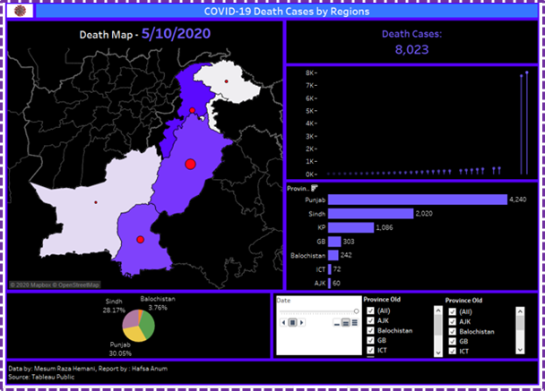

Death Cases

**Components:**

This dashboard has 5 major components:

**· Map:** It speaks to the development in Death Cases. This depends on longitudes and scopes. Details are appeared by regions. For sheet scope Color shows the Death cases while size shows total of Death cases.

**· Line Chat:** This is showing the examples of total Death Cases as demonstrated by date. The data is Filtered on Provinces.

**· Bar Chart:** It shows comparable assessment of Death cases for each district.

**· Count:** It shows the total consider of Death cases per date.

**· Pie Chart:** This is showing the degree of Death cases for each area.

**· Filter:** It Filters through the territories. In extension to that, one can in like manner see the Map and Lines of his/her domain of interest.

**· Data pages:** It portrays how the Death cases have extended by the movement of time.

**Date Legend:**

Date legend engages one to see the amount of Death Cases in different sorts of perceptions by picking the essential date. Moreover, one can in like manner see the quick addition by tapping on the play button.

**Analysis:**

This dashboard is indicating Death Cases as per dates. All the diagrams in the above dashboard shows the colossal improvement in number of Death cases. The maximum number of Death Cases are **6991** though in this it is demonstrating the Death cases as indicated by date **10–05–2020** which are **8023**.In the start from **04–04–2020** to **05–05–2020** the death cases are more in the territories of Sindh and Khyber-Pakhtunkhwa however from the bar and pie plot with the movement of time we can see that Punjab has the most vital number of Death cases. Additionally, Kashmir has the most diminished number of cases.

**3. Territorial Analysis of COVID-19 Recovered Cases:**

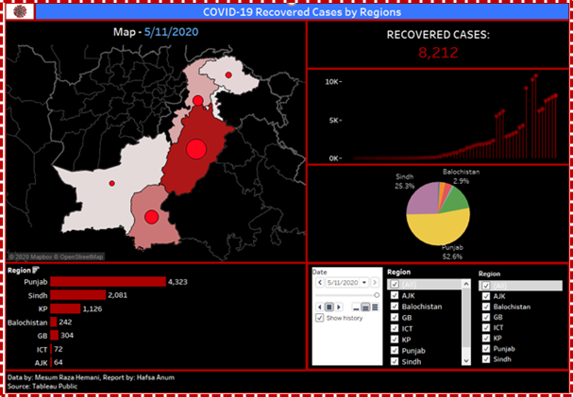

**Recovered Cases**

**Components:**

This dashboard has 5 major components:

**· Map:** It speaks to the extension in Recovered Cases. This depends on longitudes and scopes. Details are appeared by territories. For sheet scope Color shows the Recovered Cases though size shows aggregate of Recovered.

**· Line Chat:** This is showing the examples of total Recovered Cases as demonstrated by date. The data is Filtered on Provinces.

**· Bar Chart:** It shows comparable assessment of Recovered Cases for each area.

**· Count:** It shows the total consider of Recovered Cases per date.

**· Pie Chart:** This is showing the degree of Recovered Cases for each area.

**· Filter:** It Filters through the areas. In extension to that, one can moreover observe the Map and Lines of his/her region of interest.

**· Data pages:** It delineates how the Recovered cases have extended by the movement of time.

**Date Legend:**

Date legend enables one to see the amount of Recovered Cases in different sorts of perceptions by picking the important date. Also, one can in like manner see the quick augmentation by tapping on the play button.

**Analysis:**

This dashboard is indicating Recovered Cases as indicated by dates. All the charts in the above dashboard shows the colossal improvement in number of Recovered cases. The absolute number of Recovered Cases are **135542** while in this it is indicating the Recovered Cases as per date **11–05–2020** which are **8212**. Close to the beginning, the extension was consistent yet, in April and may it has got enough pace. In the first place from Bar Chart we can see that from **23–03–2020** to **04–04–2020** the recovered cases are more in the areas of Sindh and Khyber-Pakhtunkhwa yet with the movement of time from the bar and pie plot we can see that Punjab has the most important number of Recovered cases. Also, Kashmir has the most decreased number of Recovered cases.

**4. Territorial Analysis of COVID-19 Suspected Cases:**

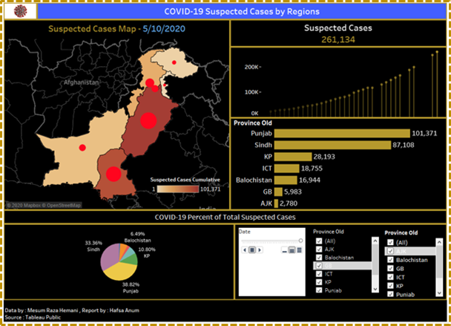

**Suspected Cases**

**Components:**

This dashboard 5 major components:

**· Map:** It speaks to the development in Suspected Cases. This depends on longitudes and scopes. Details are appeared by regions. For sheet scope Color shows the Suspected Cases while size shows aggregate of Suspected.

**· Line Chart:** This is exhibiting the examples of total Suspected Cases as showed by date. The data is Filtered on Provinces.

**· Bar Chart:** It shows comparable assessment of Suspected Cases for each locale.

**· Count:** It shows the total consider of Suspected Cases per date.

**· Pie Chart:** This is demonstrating the degree of Suspected Cases for each area.

**· Filter:** It Filters through the territories. In development to that, one can in like manner see the Map and Lines of his/her domain of interest.

**· Data pages:** It portrays how the Suspected cases have extended by the movement of time.

**Date Legend:**

Date legend engages one to see the amount of Suspected Cases in different sorts of perceptions by picking the vital date. Furthermore, one can in like manner see the quick addition by tapping on the play button.

**Analysis:**

This dashboard is demonstrating Suspected Cases as indicated by dates. All the charts in the above dashboard shows the enormous advancement in number of Suspected cases. The all-out number of Suspected Cases are **3091814** while in this it is demonstrating the Suspected Cases as indicated by date **10–05–2020** which are **261,134**. Close to the beginning, the development was consistent yet, in April and may it has got enough pace. We can see that toward the beginning the Suspected cases are more in Sindh yet with the movement of time from the bar and pie diagram we can see that Punjab has the most vital number of cases. In addition, Kashmir has the most diminished number of Suspected cases.

**5. Territorial Analysis of COVID-19 Tests Performed and Test Positive Cases:**

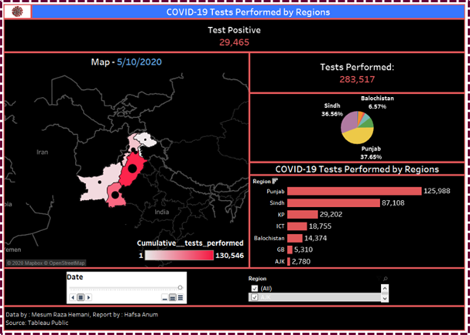

**Tests Performed and Test Positive Cases**

**Components:**

This dashboard has 5 major Components:

**· Map:** It speaks to the development in Tests Performed and Positive Cases. This depends on longitudes and scopes. Details are appeared by areas. For sheet scope Color shows the Tests Performed while size shows entirety of Tests Performed and Test Positive Cases.

**· Bar Chart:** It shows similar examination of Tests Performed for every territory.

**· Pie Chart:** This is showing the degree of Tests Performed for each area.

**· Test Positive Count:** It is demonstrating aggregate of Test Positive Cases as indicated by date.

**· Tests Performed Count:** It is indicating the total of Tests Performed by date.

**· Filter:** It Filters through the areas. In extension to that, one can in like manner see the Map of his/her domain of interest.

**· Data pages:** It delineates how the Tests Performed and Test Positive Cases have expanded by the movement of time.

**Date Legend:**

Date legend enables one to see the number of Tests Performed and Test Positive Cases in different sorts of perceptions by picking the fundamental date. Moreover, one can similarly observe the quick addition by tapping on the play button.

**Analysis:**

This dashboard is demonstrating Tests Performed and Test Positive Cases as indicated by dates. All the charts in the above dashboard shows absolute tests performed and positive cases. The absolute number of Tests Performed are **5080958** and Test Positive Cases are **474051** while in this it is indicating the Tests Performed and Test Positive Cases as indicated by date **10–05–2020** which are **29465** and **283,517**. Close to the beginning, the extension was consistent yet, in April and may it has got enough pace. From the bar and pie diagram we can see that more Tests are Performed in the Punjab Whereas in Kashmir minimal number of Tests are performed.

**6. Analysis of COVID-19 Travelers Screened:**

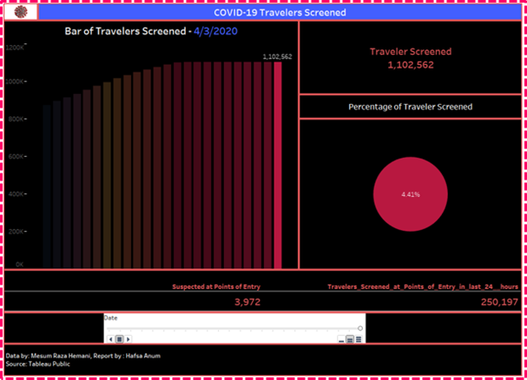

**Travelers Screened**

**Components:**

This dashboard has 4 main Components:

**· Bar Chart:** It shows the expanding number of travelers screened. This plot the entirety of Cumulative travelers Screened for Date. Shading shows whole of Cumulative travelers Screened.

**· Pie Chart:** This is showing the degree of Travelers Screened.

**· Count:** It shows the absolute consider of Travelers Screened per date.

**· Description:** It shows depiction about Travelers which are associated at focuses with section and suspected in most recent 24 hours.

**· Data pages:** It portrays how the Travelers are screened with the movement of time.

**Data Legend:**

Date legend engages one to see the number of Travelers Screened in different sorts of observations by picking the vital date. Moreover, one can in like manner see the quick augmentation by tapping on the play button.

**Analysis:**

This dashboard is demonstrating Travelers Screened by dates. All the charts in the above dashboard shows enormous advancement of Traveler’s Screened. In this it is indicating the Travelers Screened by date **03–04–2020** which are **1102562**. At the beginning, the extension was consistent yet, in April it has got enough pace. From the bar layout we can see that more Travelers are Screened with the movement of time.

**7. Analysis of Returnees and Advised Quarantine:**

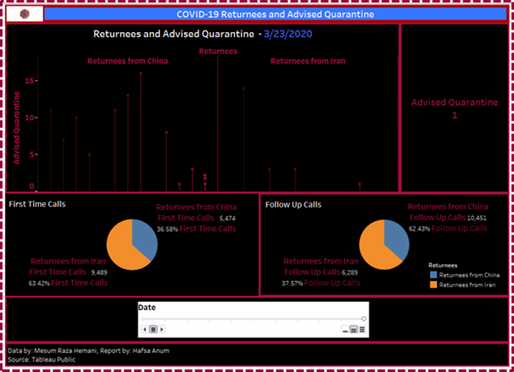

**Returnees and Advised Quarantine**

**Components:**

This dashboard has 4 major components:

**· Bar Chart:** It speaks to the patterns of aggregate of Advised Self Quarantine and entirety of Advised Self Quarantine for Date separated by Returnees on page 3/23/2020. The imprints are marked by entirety of Advised Self Quarantine.

**· Pie Chart:** This is demonstrating the degree of First-time calls and Follow up Calls.

**· Count:** It is demonstrating total of Advised Quarantine according to date.

**· Data Pages:** It portrays how the Returnees and Advised Quarantine, First Time and Follow up Calls have expanded by the movement of time.

**Data Legend:**

Date legend engages one to see the number of Returnees and Advised Quarantine, First Time and Follow up Calls in different sorts of perceptions by picking the fundamental date. Moreover, one can in like manner see the quick addition by tapping on the play button.

**Analysis:**

This dashboard is demonstrating Returnees and Advised Quarantine, First Time and Follow up Calls as indicated by dates. All the diagrams in the above dashboard shows the enormous improvement in number of Returnees and Advised Quarantine, First Time and Follow up Calls. The all-out number of Advised Quarantine are **107** while in this it is demonstrating the Advised Quarantine as per date **23–03–2020** which are **1**. From the pie diagram we can see that Pakistan got First Time class from Iran and Then the Follow up calls from China.

**8. Territorial Overview of COVID-19 Hospitals:**

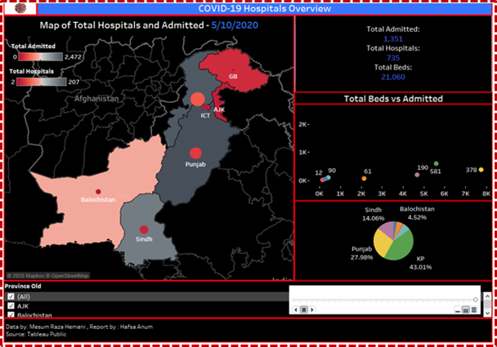

**Hospitals Overview**

**Components:**

This dashboard has 4 major components:

**· Map:** It speaks to Total Hospitals and Total admitted individuals in the Hospitals. This depends on longitudes and scopes. Details are appeared by regions. For sheet scope Color shows Total Hospitals though size shows aggregate of Total Admitted.

**· Count:** It shows the all-out entirety of Hospitals, People admitted and Beds according to date.

**· Scatter Plot:** It shows a correlation of all out beds and admitted individuals in the emergency clinic as indicated by Region.

**· Pie Chart:** This is demonstrating the degree of Admitted People for each area.

**· Filter:** It filters through the regions. In extension to that, one can in like manner see the Map of his/her region of interest.

**· Data pages:** It portrays how the Hospitals and complete admitted individuals have extended by the movement of time.

**Data Legend:**

Date legend enables one to see the amount of Hospital Overview in different sorts of perceptions by picking the necessary date. What’s more, one can in like manner see the quick addition by tapping on the play button.

**Analysis:**

The Dashboard is demonstrating Hospitals Overview as indicated by dates. A few charts in the above dashboard shows the expanding number of Hospitals and Admitted individuals with the movement of time. In the beginning the all-out number of Hospitals are more in the Province of Sindh however with the development of time all out number of hospitals are Increased in the territory of Punjab and from the pie plot we can see that Admitted individuals are more in the region of Khyber-Pakhtunkhwa and from the date **10–04–2020** to **04–05–2020** the all-out number of Beds are more in the areas of Sindh and Khyber-Pakhtunkhwa yet with the extension of time the all-out number of beds are expanded in the region of Punjab.

**9. Territorial Analysis of Total Transmissions:**

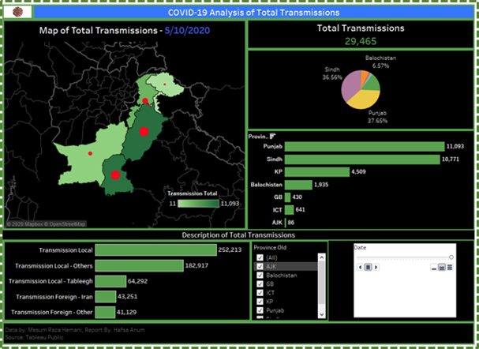

**Total Transmissions**

**Components:**

This dashboard has 5 major Components:

· **Map:** It speaks to the extension in Total Transmissions. This depends on longitudes and scopes. Details are appeared by territories. For sheet scope Color shows the Total Transmissions while size shows whole of Total Transmissions.

**· Pie Chart:** This is showing the degree of Total Transmissions for each locale.

**· Bar Chart:** It shows comparable assessment of Total Transmissions for each locale.

**· Count:** It is indicating whole of total Transmissions according to date.

**· Description:** It is indicating the diverse total of transmissions.

**· Filter:** It sift through the regions. In development to that, one can similarly observe the Map of his/her region of interest.

**· Data pages:** It portrays how the Total Transmissions have extended by the movement of time.

**Data Legend:**

Date legend engages one to see the amount of Total Transmissions in different sorts of Perceptions by picking the necessary date. Furthermore, one can similarly observe the quick augmentation by tapping on the play button.

**Analysis:**

This dashboard is demonstrating Total Transmissions as per dates. All the charts in the above dashboard shows the colossal advancement in number of Total Transmissions. The total number of Transmissions are **336600** though in this it is demonstrating the Transmissions as indicated by date **10–05–2020** which are **29,465**. Before all else there are not many transmitted individuals however in April and May we have seen surpassed number of transmitted individuals. From the bar and pie diagram we can see that Punjab has the most significant number of individuals Whereas, Kashmir has the most decreased number of Transmitted People.

**10. Territorial Analysis of COVID-19 Quarantine Facilities:**

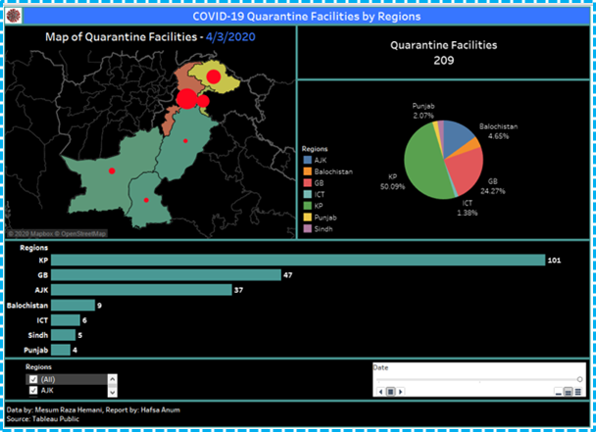

**Quarantine Facilities**

**Components:**

This dashboard shows 4 components:

**· Map:** It speaks to the extension in Quarantine Facilities. This depends on longitudes and scopes. Details are appeared by territories. For sheet scope Color shows the Quarantine Facilities though size shows aggregate of Quarantine Facilities. The view is sifted on regions.

**· Pie Chart:** This is demonstrating the degree of Quarantine Facilities for each locale

**· Bar Chart:** It shows comparable assessment of Quarantine Facilities for each locale.

**· Count:** It shows whole of Quarantine Facilities according to date.

**· Filter:** It filters out the provinces. In expansion to that, one can likewise see the Map of his/her territory of intrigue.

**· Data pages:** It delineates how the Quarantine Facilities have extended by the movement of time.

**Data Legend:**

Date legend enables one to see the amount of Quarantine Facilities in different sorts of recognition by picking the important date. Also, one can in like manner see the quick augmentation by tapping on the play button.

**Analysis:**

This dashboard is indicating Quarantine Facilities as per dates. All the charts in the above dashboard shows the colossal advancement in number of Quarantine Facilities. The complete number of Quarantine Facilities are **581** while in this it is indicating the Quarantine Facilities as per date **03–04–2020** which are **209**.In the start, the Quarantine Facilities are less however with the movement of time they have expanded. From the bar and pie layout we can see that Khyber-Pakhtunkhwa has the best number of Quarantine Facilities Whereas Punjab has the most decreased number of Facilities.

**Conclusion:**

To control corona Virus, we must take care of social distances and use mask and sanitizers because Pakistan is a developing country and it has low quarantine facilities and technologies and if virus spread in Pakistan than we have to face a critical condition to survive.

Good things will Happen soon Be positive.

**Data Behind Visuals:**

[***Corona Virus Pakistan Dataset 2020***  
Corona Virus Pakistan Dataset 2020www.kaggle.com](https://www.kaggle.com/mesumraza/corona-virus-pakistan-dataset-2020)

**Project GitHub Repository:**

[**Hafsa-Anum/Covid19-DSPROJECT-Hafsa-Anum**  
*Covid19 Visualizations . Contribute to Hafsa-Anum/Covid19-DSPROJECT-Hafsa-Anum development by creating an account on…*github.com](https://github.com/Hafsa-Anum/Covid19-DSPROJECT-Hafsa-Anum)

**Visuals:**

Confirmed Cases *:* <https://public.tableau.com/profile/hafsaanum#!/vizhome/ConfirmedCases_15898179432520/ConfirmedCasesFinal>

Death Cases: <https://public.tableau.com/profile/hafsaanum#!/vizhome/ConfirmedDeaths/DeathCases>

Recovered Cases: <https://public.tableau.com/profile/hafsaanum#!/vizhome/RecoveredCases_15899011756330/RecoveredCases>

Suspected Cases*:* <https://public.tableau.com/profile/hafsaanum#!/vizhome/SuspectedCases/SuspectedCases>

Tests Performed and Test Positive Cases:<https://public.tableau.com/profile/hafsaanum#!/vizhome/TestsPerformed/TestsPerformed>

Travelers Screened: <https://public.tableau.com/profile/hafsaanum#!/vizhome/TravelersScreened/TravelersScreened>

Returnees and Advised Quarantine: <https://public.tableau.com/profile/hafsaanum#!/vizhome/ReturneesandAdvisedquarantine/ReturneesandAdvisedQuarantine_1>

Hospitals Overview: <https://public.tableau.com/profile/hafsaanum#!/vizhome/HospitalsOverview/HospitalsOverview>

Total Transmissions: <https://public.tableau.com/profile/hafsaanum#!/vizhome/TotalTramsmissions/TotalTransmissions>

Quarantine Facilities: <https://public.tableau.com/profile/hafsaanum#!/vizhome/QuarantineFacilities/QuarantineFacilities>